Project Design Phase-II
Data Flow Diagram & User Stories
Date | 06/09/2026
Team ID | Servicenow
Project Name | Automated Network Request Management
Maximum Marks | 4 Marks

Data Flow Diagrams:
A Data Flow Diagram (DFD) is a traditional visual representation of the information flows within a system. A neat and clear DFD can depict the right amount of the system requirement graphically. It shows how data enters and leaves the system, what changes the information, and where data is stored.
Automated Network Request Management — DFD Level 0:
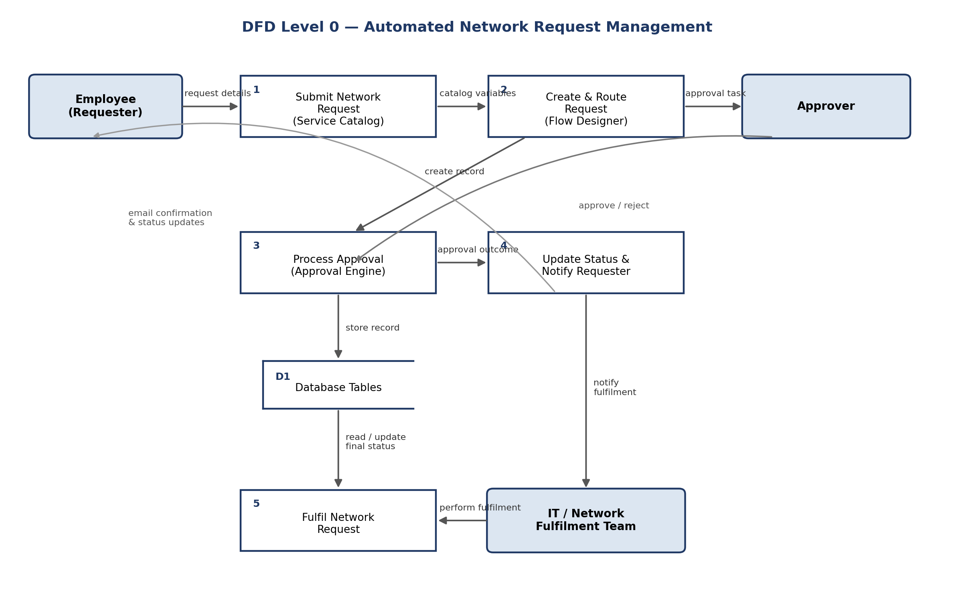

User Stories
Use the below template to list all the user stories for the product.
User Type | Functional Requirement (Epic) | User Story No. | User Story / Task | Acceptance Criteria | Priority | Release
Employee  (Requester) | Network Request Submission | USN-1 | As a requester, I can submit a network request through the Service Portal by filling in connection type, address, and payment details. | Request record is created with a unique NRM-prefixed number | High | Sprint-1
Employee  (Requester) | Conditional Form Behaviour | USN-2 | As a requester, I only see the “Existing ID” field when I select Type of Connection = Existing. | Field is hidden for New connections and shown for Existing | Medium | Sprint-1
Employee  (Requester) | Notifications | USN-3 | As a requester, I receive an email confirming my request was submitted. | Confirmation email is received immediately after submission | High | Sprint-1
Employee  (Requester) | Notifications | USN-4 | As a requester, I receive an email once my request is approved or rejected. | Status email received matching the approval outcome | High | Sprint-2
Approver  (Manager) | Approval Routing | USN-5 | As an approver, I receive a request in my approval queue to review and approve or reject. | Approval record appears with correct request details attached | High | Sprint-1
IT / Network  Fulfilment Team | Access Control | USN-6 | As a fulfilment team member, I can view and update approved requests assigned to my role. | Only users with the u_database_tables_user role can access request records | Medium | Sprint-2
IT Admin | Automated Record Creation | USN-7 | As an IT admin, I can see that every submitted request automatically creates a corresponding Database Tables record with no manual entry. | Record fields match the submitted catalog variables exactly | High | Sprint-1

